SEMESTER TWO
Papers written by
Australian Maths Software

YEAR 11

MATHEMATICS APPLICATIONS
Units 1 & 2
REVISION 1
2016

Section One
(Calculator–free)

Name: _________________________________

Teacher: ________________________________

TIME ALLOWED FOR THIS SECTION

Reading time before commencing work: 5 minutes
Working time for section: 50 minutes

MATERIAL REQUIRED / RECOMMENDED FOR THIS SECTION

To be provided by the candidate
Standard items: pens, pencils, pencil sharpener, highlighter, eraser, ruler.

IMPORTANT NOTE TO CANDIDATES
No other items may be taken into the examination room. It is your responsibility to ensure that you do not have any unauthorised notes or other items of a non–personal nature in the examination room. If you have any unauthorised material with you, hand it to the supervisor before reading any further.

To be provided by the supervisor
Question/answer booklet for Section One.
A formula sheet which may also be used for Section Two.
Structure of this examination

 | Number of questions available | Number of questions to be answered | Working time (minutes) | Marks available | Percentage of exam
Section One  Calculator—free | 6 | 6 | 50 | 52 | 35
Section Two  Calculator—assumed | 10 | 10 | 100 | 98 | 65
Total marks |  |  |  | 150

Instructions to candidates

1. The rules for the conduct of this examination are detailed in the Information Handbook.
Sitting this examination implies that you agree to abide by these rules.

2. Write your answer in the Question/Answer booklet.

3. You must be careful to confine your responses to the specific questions asked and to
follow any instructions that are specific to a particular question.

4. Spare pages are provided at the end of this booklet. If you need to use them, indicate
in the original answer space where the answer is continued i.e. give the page number.

5. Show all your working clearly. Your working should be in sufficient detail to allow your
answers to be checked readily and for marks to be awarded for reasoning. Incorrect
answers given without supporting reasoning cannot be allocated any marks. For any
question or part question worth more than two marks, valid working or justification is
required to receive full marks. If you repeat an answer to any question, ensure that you
cancel the answer you do not wish to have marked.

6. It is recommended that you do not use pencil, except in diagrams.

7. The Formula Sheet is not to be handed in with your Question/Answer booklet.

Section One: Calculator–free 52 marks

This section has six (67) questions. Attempt all questions.
Working time: 50 minutes

Question 1 (8 marks)

(a) (i) Classify whether “place of birth” is nominal or ordinal. Give your reasons. (2)

(ii) Use a bar chart to illustrate the following data

(3)

(b) Describe the distribution of the data shown on the histogram below. (3)

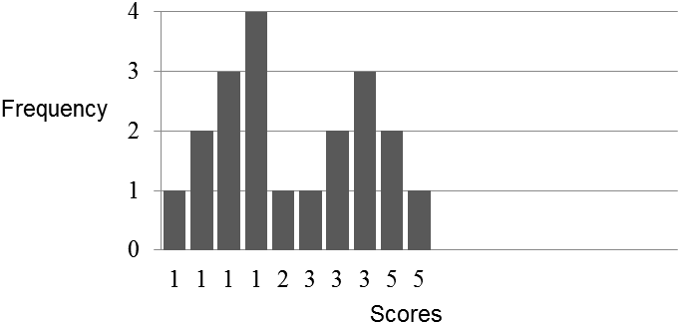

Question 2 (7 marks)

Calculate the following where possible. If the calculation is not possible, explain why this
is so.
(a) 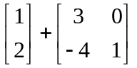 (2)

(b) 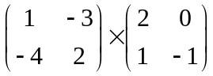 (2)

(c) 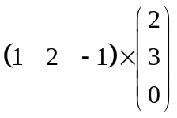 (1)

(d) Find 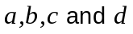 such that 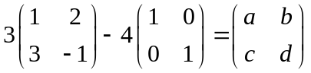. (2)

Question 3 (9 marks)

(a) Consider the linear function on the set of axes below.

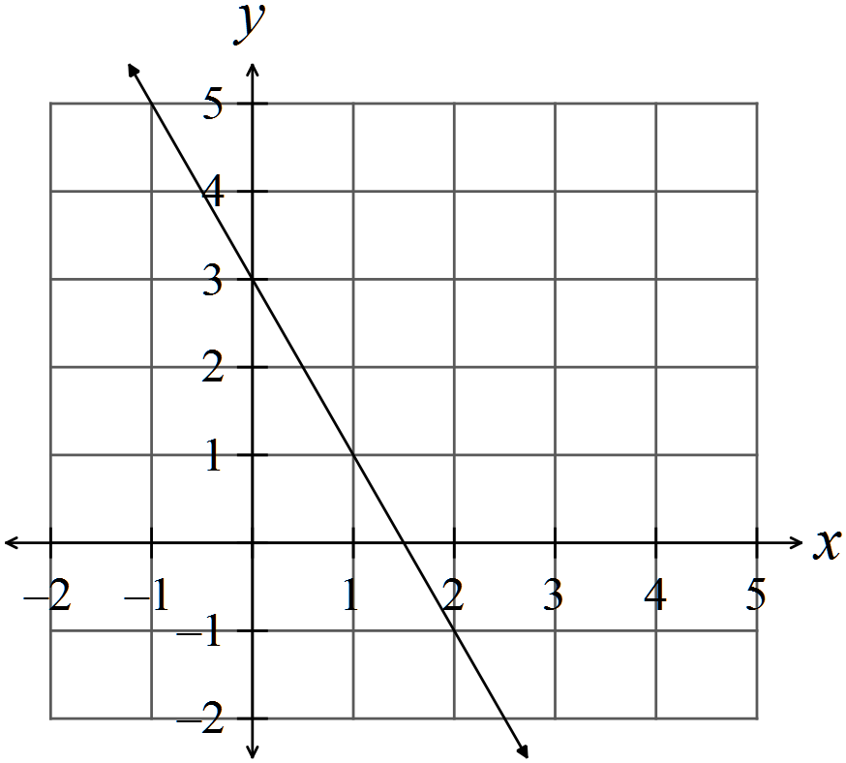

(i) Write down the gradient and the intercepts of the linear function. (2)

(ii) Write down the equation of the linear function. (2)

(b) Sketch a linear function on the set of axes below such that the y intercept is -1 and the gradient is 2/3. (2)
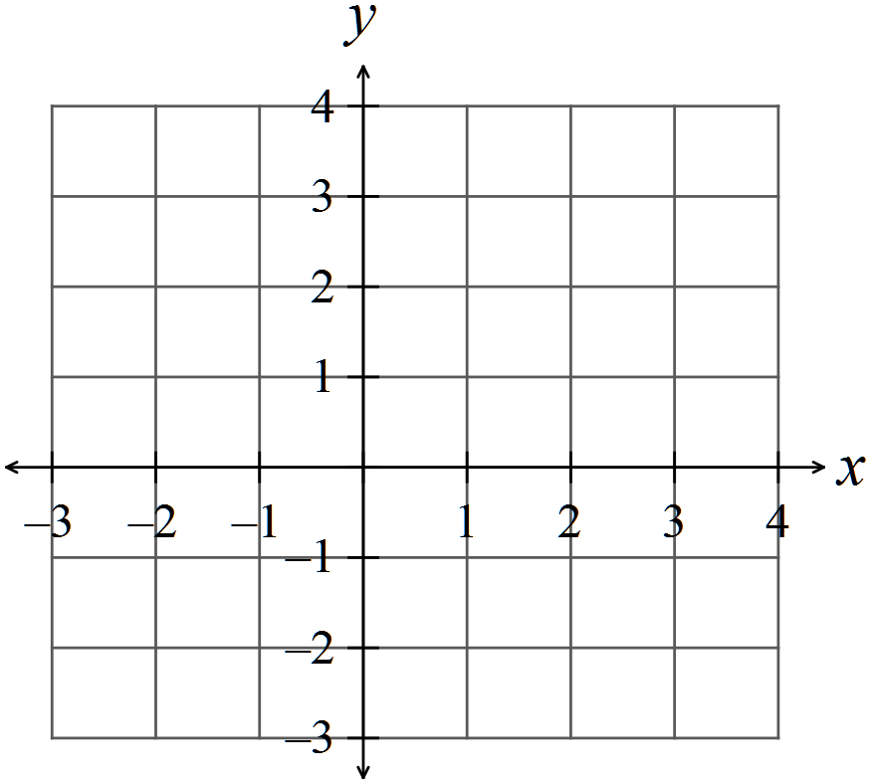

(c) Find 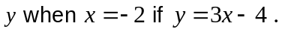 (1)

(d) A car yard makes $600 profit for every Honda car sold.

Write down the equation of a linear function that represents the profit on Honda sales for cars sold. (2)


Question 4 (12 marks)

Billy charged $20 and hour for gardening.

(a) Write the relationship between total cost (C) and number of hours worked (t) by Billy. (2)

Johnny charged $50 to bring his truck to cart rubbish away and then $15 an hour to do
the gardening.

(b) Write the relationship between total cost (C) and number of hours worked (t) by
Johnny. (2)

(c) Sketch both relationships on the set of axes below. Label each graph. (4)

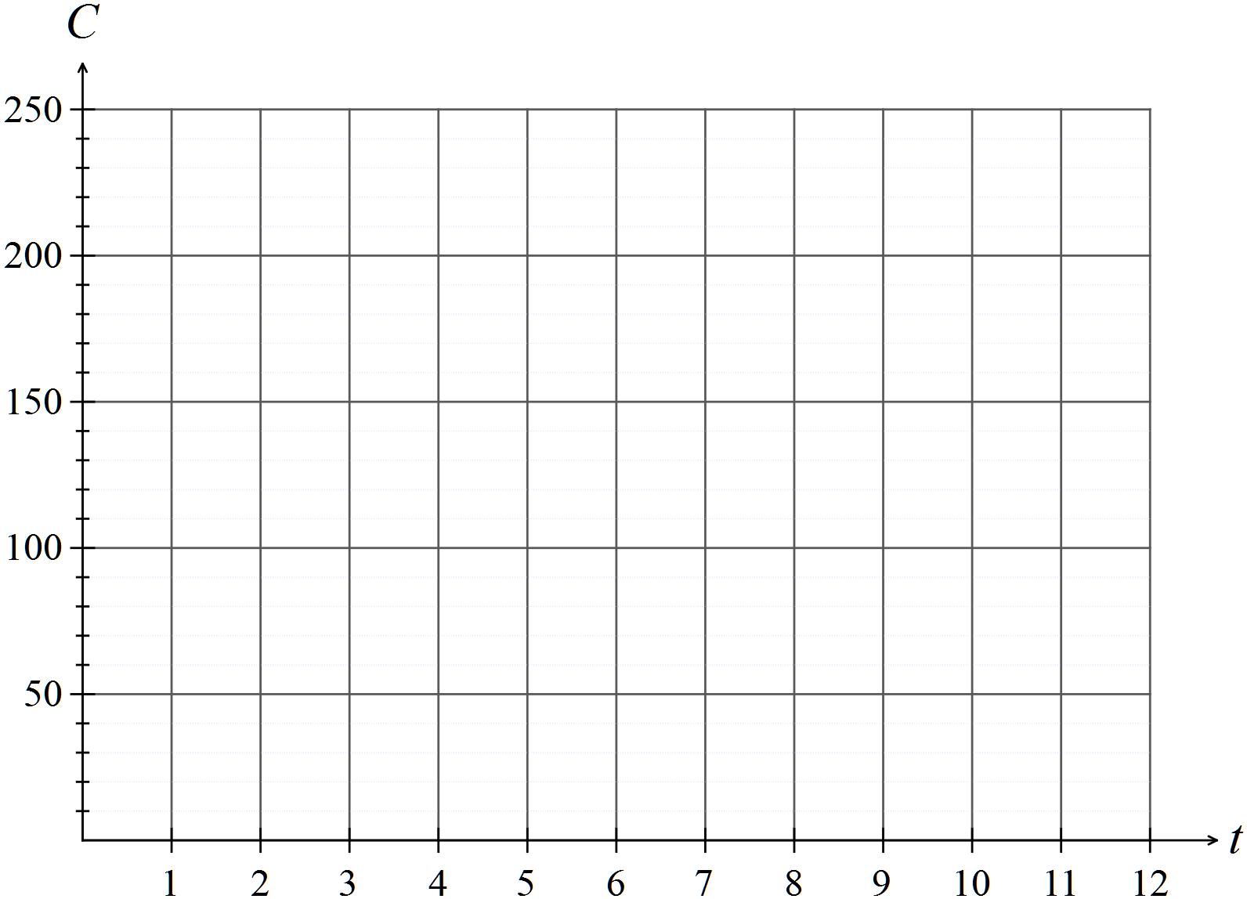

(d) Which man is the cheaper for 7 hours work? (2)

(e) After how many hours are the costs the same? (2)

Question 5 (10 marks)

Consider the box plot below

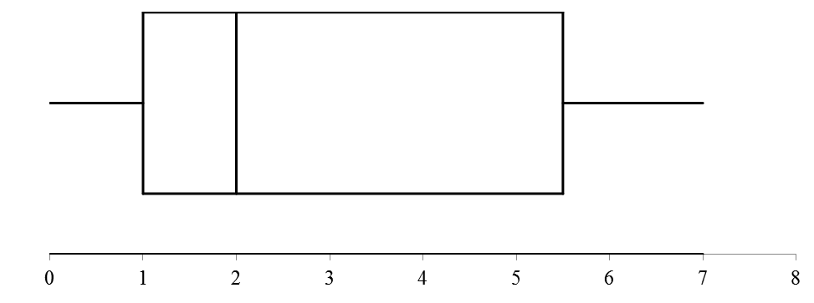

(a) Determine the range, the median and the interquartile range. (3)

(b) List two statistical measures that cannot be determined from a box and whisker plot.
(2)

(c) Compare and contrast the box plot above with the box plot below. (5)

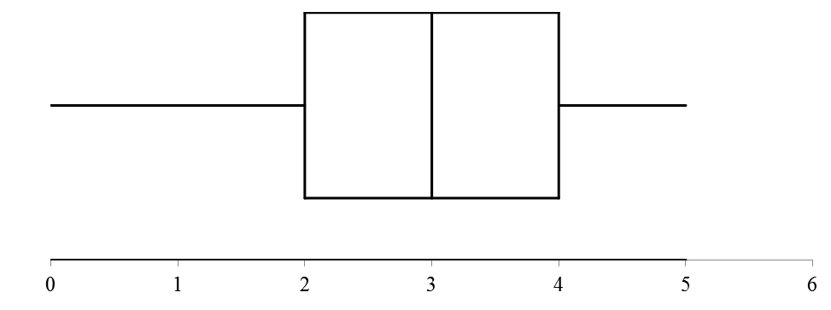

Question 6 (6 marks)

Sketch the following on the set of axes below:

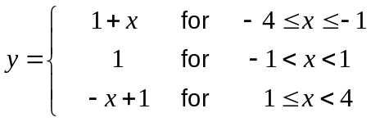 (6)

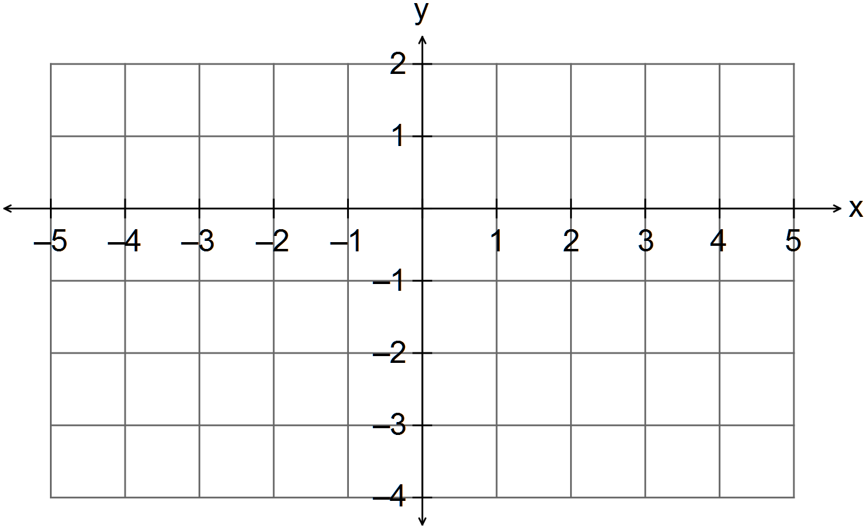

END OF SECTION ONE

